Figure P7.1 Structure and contents of the Ch07_ConstructCo database

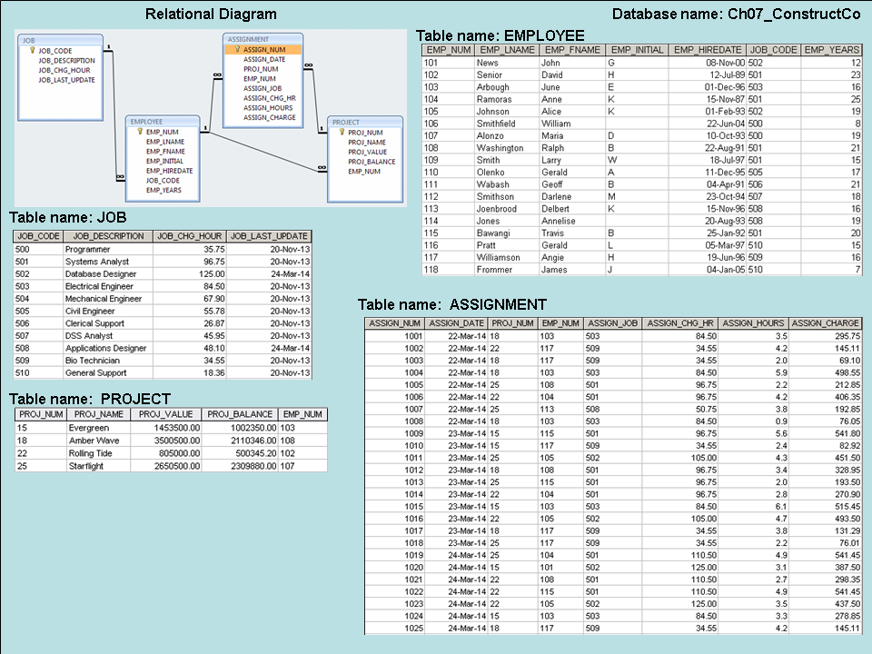

1. **SQL code to create the table structure for a table EMP_1. (Note: JOB_CODE is the FK to JOB.):**

CREATE TABLE EMP_1 (

EMP_NUM CHAR(3) PRIMARY KEY,

EMP_LNAME VARCHAR(15) NOT NULL,

EMP_FNAME VARCHAR(15) NOT NULL,

EMP_INITIAL CHAR(1),

EMP_HIREDATE DATE,

JOB_CODE CHAR(3),

FOREIGN KEY (JOB_CODE) REFERENCES JOB);

1. **SQL code to enter the first two rows for the table shown in Figure P7.2:**

Figure P7.2 The contents of the EMP_1 table

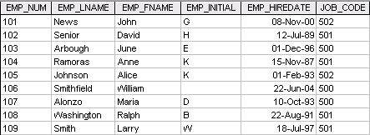

INSERT INTO EMP_1 VALUES (‘101’, ‘News’, ‘John’, ‘G’, ’08-Nov-00’, ‘502’);

INSERT INTO EMP_1 VALUES (‘102’, ‘Senior’, ‘David’, ‘H’, ’12-Jul-89’, ‘501’);

1. **SQL code that will list all attributes for a job code of 502:**

SELECT *

FROM EMP_1

WHERE JOB_CODE = ‘502’;

1. **SQL code to change the job code to 501 for the person whose employee number (EMP_NUM) is 107:**

UPDATE EMP_1

SET JOB_CODE = ‘501’

WHERE EMP_NUM = ‘107’;

1. **SQL code to delete the row for the person named William Smithfield, who was hired on June 22, 2004, and whose job code classification is 500:**

DELETE FROM EMP_1

WHERE EMP_LNAME = 'Smithfield'

AND EMP_FNAME = 'William'

AND EMP_HIREDATE = '22-June-04'

AND JOB_CODE = '500';

1. **Write the SQL code to create a copy of EMP_1, naming the copy EMP_2. Then write the SQL code that will add the attributes EMP_PCT and PROJ_NUM to its structure. The EMP_PCT is the bonus percentage to be paid to each employee. The new attribute characteristics are:**

**EMP_PCTNUMBER(4,2)**

**PROJ_NUMCHAR(3)**

**Solution A:**

CREATE TABLE EMP_2 (

EMP_NUM CHAR(3) NOT NULL UNIQUE,

EMP_LNAME VARCHAR(15) NOT NULL,

EMP_FNAME VARCHAR(15) NOT NULL,

EMP_INITIAL CHAR(1),

EMP_HIREDATE DATE NOT NULL,

JOB_CODE CHAR(3) NOT NULL,

PRIMARY KEY (EMP_NUM),

FOREIGN KEY (JOB_CODE) REFERENCES JOB);

INSERT INTO EMP_2 SELECT * FROM EMP_1;

ALTER TABLE EMP_2

ADD (EMP_PCT NUMBER (4,2)),

ADD (PROJ_NUM CHAR(3));

**Solution B:**

CREATE TABLE EMP_2 AS SELECT * FROM EMP_1;

ALTER TABLE EMP_2

ADD (EMP_PCT NUMBER (4,2)),

ADD (PROJ_NUM CHAR(3));

1. **Write the SQL code to change the EMP_PCT value to 3.85 for the person whose employee number (EMP_NUM) is 103. Next, write the SQL command sequences to change the EMP_PCT values as shown in Figure P7.9:**

Figure P7.9 The contents of the EMP_2 table

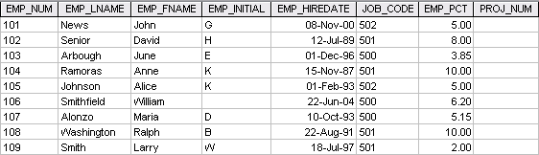

UPDATE EMP_2

SET EMP_PCT = 3.85

WHERE EMP_NUM = '103';

To enter the remaining EMP_PCT values, use the following SQL statements:

UPDATE EMP_2

SET EMP_PCT = 5.00

WHERE EMP_NUM = ‘101’;

UPDATE EMP_2

SET EMP_PCT = 8.00

WHERE EMP_NUM = ‘102’;

Follow this format for the remaining rows.

1. **SQL code that will change the project number (PROJ_NUM) to 18 for all employees whose job classification (JOB_CODE) is 500:**

UPDATE EMP_2

SET PROJ_NUM = '18'

WHERE JOB_CODE = '500';

1. **SQL code that will change the project number (PROJ_NUM) to 25 for all employees whose job classification (JOB_CODE) is 502 or higher:**

Figure P7.11 The EMP_2 table contents after the modification

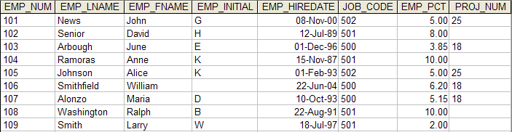

UPDATE EMP_2

SET PROJ_NUM = '25'

WHERE JOB_CODE > = '502'

1. **SQL code that will change the PROJ_NUM to 14 for those employees who were hired before January 1, 1994 and whose job code is at least 501:**

UPDATE EMP_2

SET PROJ_NUM = '14'

WHERE EMP_HIREDATE <= ' 01-Jan-94'

AND JOB_CODE >= '501';

1. **Write the two SQL command sequences required to:**

There are many ways to accomplish both tasks. We are illustrating the shortest way to do the job next.

* 1. **Create a temporary table named TEMP_1 whose structure is composed of the EMP_2 attributes EMP_NUM and EMP_PCT.**
  2. **Copy the matching EMP_2 values into the TEMP_1 table.**

CREATE TABLE TEMP_1

AS SELECT EMP_NUM, EMP_PCT

FROM EMP_2;

An alternate way would be to create the table and then, use an INSERT with sub-select to populate the rows.

CREATE TABLE TEMP_1 AS (

EMP_NUM CHAR(3),

EMP_PCT NUMBER(4,2));

INSERT INTO TEMP_1

SELECT EMP_NUM, EMP_PCT FROM EMP_2;

1. **SQL code required to list all employees whose last names start with Smith:**

SELECT *

FROM EMP_2

WHERE EMP_LNAME LIKE ‘Smith%’;

1. **Using the EMPLOYEE, JOB, and PROJECT tables in the** ConstructCo **database (see Figure P7.1), write the SQL code that will produce the results shown in Figure P7.16:**

Figure P7.16 The query results for Problem 16

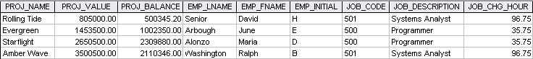

SELECT PROJ_NAME, PROJ_VALUE, PROJ_BALANCE, EMPLOYEE.EMP_LNAME, EMP_FNAME, EMP_INITIAL, EMPLOYEE.JOB_CODE, JOB.JOB_DESCRIPTION, JOB.JOB_CHG_HOUR

FROM PROJECT, EMPLOYEE, JOB

WHERE EMPLOYEE.EMP_NUM = PROJECT.EMP_NUM

AND JOB.JOB_CODE = EMPLOYEE.JOB_CODE;

1. **SQL code that will produce a virtual table named REP_1:**

CREATE VIEW REP_1 AS

SELECT PROJ_NAME, PROJ_VALUE, PROJ_BALANCE, EMPLOYEE.EMP_LNAME, EMP_FNAME, EMP_INITIAL, EMPLOYEE.JOB_CODE, JOB.JOB_DESCRIPTION, JOB.JOB_CHG_HOUR FROM PROJECT, EMPLOYEE, JOB

WHERE EMPLOYEE.EMP_NUM = PROJECT.EMP_NUM AND JOB.JOB_CODE = EMPLOYEE.JOB_CODE;

1. **Using the data in the ASSIGNMENT table, write the SQL code that will yield the total number of hours worked for each employee and the total charges stemming from those hours worked. The results of running that query are shown in Figure P7.22.**

Figure P7.22 Total hours and charges by employee

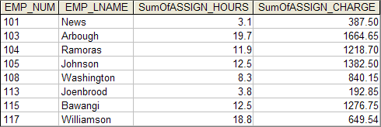

SELECT ASSIGNMENT.EMP_NUM, EMPLOYEE.EMP_LNAME, Sum(ASSIGNMENT.ASSIGN_HOURS) AS

SumOfASSIGN_HOURS,

Sum(ASSIGNMENT.ASSIGN_CHARGE) AS

SumOfASSIGN_CHARGE

FROM EMPLOYEE, ASSIGNMENT

WHERE EMPLOYEE.EMP_NUM = ASSIGNMENT.EMP_NUM

GROUP BY ASSIGNMENT.EMP_NUM, EMPLOYEE.EMP_LNAME;

1. **Write a query to produce the total number of hours and charges for each of the projects represented in the ASSIGNMENT table. The output is shown in Figure P7.23.**

Figure P7.23 Total hour and charges by project

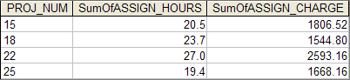

SELECT ASSIGNMENT.PROJ_NUM, Sum(ASSIGNMENT.ASSIGN_HOURS) AS SumOfASSIGN_HOURS,

Sum(ASSIGNMENT.ASSIGN_CHARGE) AS SumOfASSIGN_CHARGE

FROM ASSIGNMENT

GROUP BY ASSIGNMENT.PROJ_NUM

1. **Write the SQL code to generate the total hours worked and the total charges made by all employees. The results are shown in Figure P7.24:**

Figure P7.24 Total hours and charges, all employees

FigP7-24-Total-Hours-and-Charges

**Solution A:**

SELECT Sum(SumOfASSIGN_HOURS) AS SumOfASSIGN_HOURS,

Sum(SumOfASSIGN_CHARGE) AS SumOfASSIGN_CHARGE

FROM Q23;

**or**

SELECT Sum(SumOfASSIGN_HOURS) AS SumOfASSIGN_HOURS,

Sum(SumOfASSIGN_CHARGE AS SumOfASSIGN_CHARGE

FROM (SELECT ASSIGNMENT.PROJ_NUM,

Sum(ASSIGNMENT.ASSIGN_HOURS) AS

SumOfASSIGN_HOURS,

Sum(ASSIGNMENT.ASSIGN_CHARGE) AS

SumOfASSIGN_CHARGE

FROM ASSIGNMENT

GROUP BY ASSIGNMENT.PROJ_NUM

);

**Solution B:**

SELECT Sum(SumOfASSIGN_HOURS) AS SumOfASSIGN_HOURS,

Sum(SumOfASSIGN_CHARGE) AS SumOfASSIGN_CHARGE

FROM Q22;

or

SELECT Sum(SumOfASSIGN_HOURS) AS SumOfASSIGN_HOURS,

Sum(SumOfASSIGN_CHARGE) AS SumOfASSIGN_CHARGE

FROM (SELECT ASSIGNMENT.EMP_NUM, EMPLOYEE.EMP_LNAME, Sum(ASSIGNMENT.ASSIGN_HOURS) AS SumOfASSIGN_HOURS,

Sum(ASSIGNMENT.ASSIGN_CHARGE) AS

SumOfASSIGN_CHARGE

FROM EMPLOYEE, ASSIGNMENT

WHERE EMPLOYEE.EMP_NUM = ASSIGNMENT.EMP_NUM

GROUP BY ASSIGNMENT.EMP_NUM, EMPLOYEE.EMP_LNAME

);